Exp -1 DATA PRE-PROCESSING AND DATA CUBE

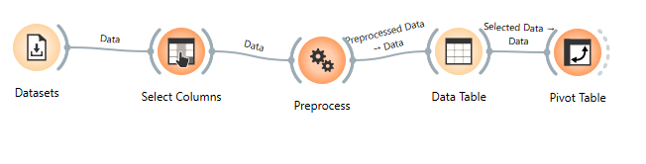dataset: adult

Exp – 2 DATA CLEANING
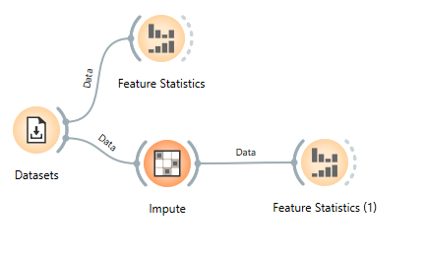
Dataset: baker’s yeast

Exp – 3 EXPLORATORY ANALYSIS
k-means & mst:
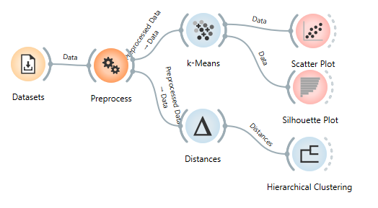
dataset: iris
Exp – 4 ASSOCIATION ANALYSIS
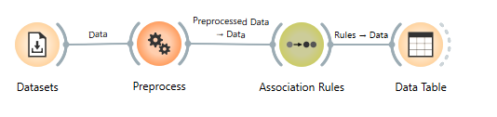
Dataset: market basket

Exp – 5 HYPOTHESIS GENERATION
Dataset: market basket

Exp – 6 TRANSFORMATION TECHNIQUES
Haar:
Code:
import numpy as np
from Orange.data import Table, Domain, ContinuousVariable

data = np.array(in_data.X)
haar = [[r.mean(), r.std(), r.max()-r.min(), np.sqrt((r**2).sum())] for r in data]
out_data = Table(Domain([ContinuousVariable(f"Haar_{i+1}") for i in range(4)]), np.array(haar))

print("Haar transform done")
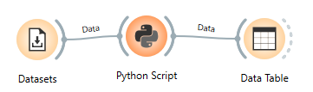

PCA:
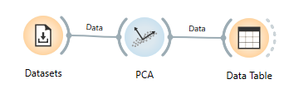
Dataset: Housing
Exp – 7 DATA VISUALIZATION
Binning:
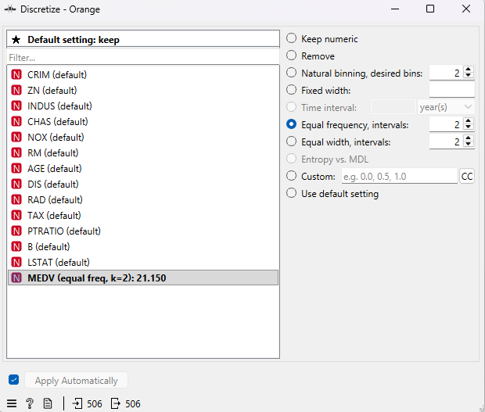
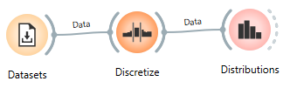

Linear regression:
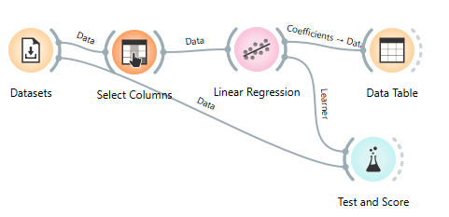
Dataset: Housing

Exp – 8 CLUSTERS ASSESSMENT
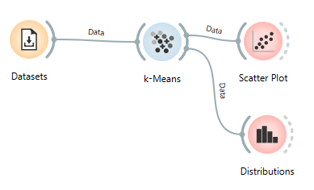
Dataset: iris
Exp - 9 HIERARCHICAL CLUSTERING
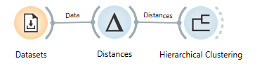
Dataset: iris

Exp – 10 SCALABILITY ALGORITHMS
Scalable Clustering (K-Means)
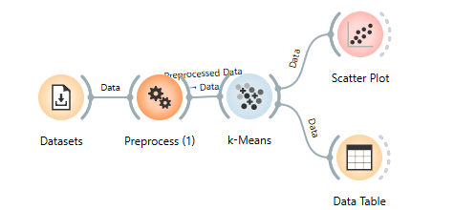
Dataset:iris
Scalable Apriori Algorithm (Association Rules)
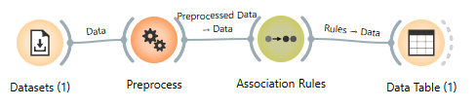
Dataset – market basket

